

Korhan Demirkaya
803191006
CompE 490
Individual Report

MOTOR CONTROL
Motor control makes sure that Yertle the Turtle moves according to its navigational needs. It consists of hardware and software.
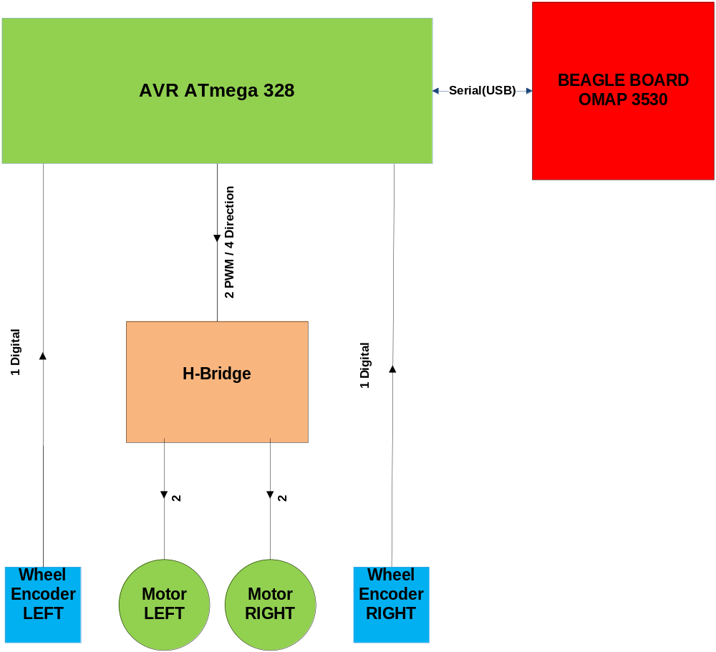

Figure I: Block Diagram of Locomotion System

1)Hardware
a)H-Bridge
Since we have 2 DC motors and we are using one motor on each wheel we needed to control them separately. H-bridges are the electronic circuits that control motors direction and the voltage. We elected a 24 V battery 4200mA battery for our motors therefore we needed a h-bridge that’s capable of handling this kind of current and preferably with 2 channels. ST’s L298 dual full-bridge driver chip is chosen for the task since it had capability of driving 2 A currents for each motor. Our preliminary tests never shown more than 1.2A in each motor so it was safe. Also the protection features and its cheap price affected our decision. We needed a circuit to connect the chip with the motors and microcontroller pins. For that reason, based on solarobotics ¹ and canadakit’s ² designs our h-bridge circuit is designed on the breadboard first then on PCB. One of the differences was the use of 1N5819 diodes to have 40 V voltage limit. The red led is lit when the direction is forward and yellow when it’s back for each motor. A 7805 regulator is used to power up the chip and the wheel encoders.
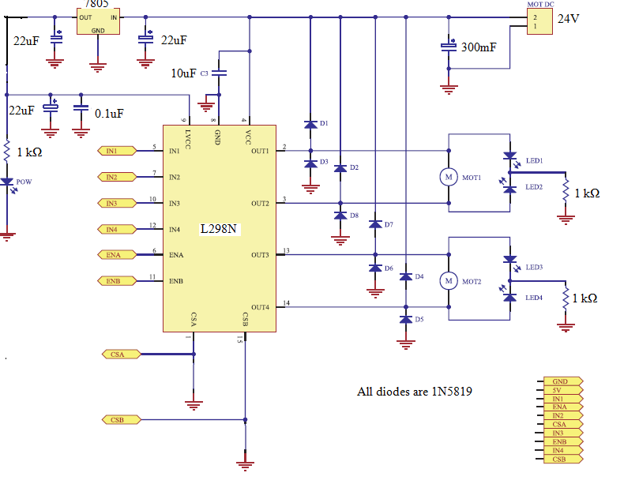
Figure II: Schematic of the h-bridge circuit

Heat dissipation was a problem especially when starting the motors because of current spikes. After having burnt many h-bridges we put a huge heat sink on L298 and the temperature was never higher than 50 ° during our experiments after this.
Each channel has one enable pin and two controls pins . The enable pin is always high ( 5 V) during operation. The control pins determines direction and the speed by PWM. We have capability to go forward, backward, turn left and right. Earlier setting controls fixed and changing the enable with PWM was another approach we tried but the voltage was not stable as it was with the final version.
Enable | Control Pin 1 | Control Pin 2 | Result
HIGH | LOW | PWM | Forward
HIGH | PWM | LOW | Backward
LOW | X | X | Stop
Table I: Logic Table for Motor Control
b)Wheel Encoders
Wheel encoders are the only sensors in locomotion system. They give us feedback about actual displacement and speed by counting number of signal changes. The wheel to gear ratio was 1: 3 and our motors have 65.5:1 ratio. At first we only used a pin that would cut the beam between the photo interrupter once, causing the signal to go from high to low once for every revolution of inner shaft. This translated to 195 inner revolutions per a wheel revolution, 2 feet of displacement. Later this resolution proved to be not enough to have a good control of the speed. The numbers per unit time was so low that a fine control was not possible. To counter this we increased the resolution by changing the pin with a PCB circle with equally spaced round holes. This way we had 12 times more resolution and the signal changed 12 times from high to low in every inner revolution. The total signal change number went up to 2364, giving us enough space to control the speed. This process will be explained more in the software section.
2364 clicks = 1 revolution of the wheel = 2 feet
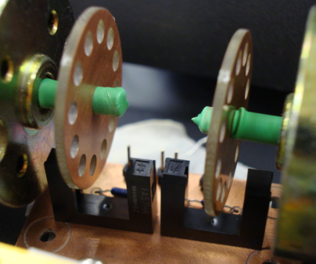
Figure III: Wheel Encoders

c)ATMega328 Microcontroller
The digital inputs need to be controlled by a microcontroller. First we were using only one microcontroller, ATMega1280 for everything and it was working fine but later we decided to dedicate a microcontroller only for the motor control. AVR’s ATMega328 is chosen for this task. 4 PWM channels (for motor control pins) and 2 external hardware interrupt channels (one for each wheel encoder signal) are employed. Also timer interrupts of it is used to keep updated motor speeds accordingly. Due to time constraints we used Arduino Deumilanove board which includes ATMega328 instead of a designed PCB version. 8-bit microcontroller communicated serially with the Beagleboard using USB output. The default frequency values for the PWM ports (1kHz for Timer 0 and 500 Hz for Timer 1) of Arduino were suitable for our motors. They made a whining sound but worked fine.
H-Bridge | Arduino Deumilanove
3 Right Motor Control 1 | 5
4 Right Motor Enable | 7
5 Right Motor Control 2 | 9
7 Left Motor Control 1 | 6
8 Left Motor Enable | 8
9 Left Motor Control 2 | 10
Table IV: Wiring between our PCB H-Bridge and Arduino I/O ports (Port 2 and 3 of Arduino are connected to right and left encoders respectively)
2)Software
Microcontroller programming was the main software component of the motor control. We followed the flow below.
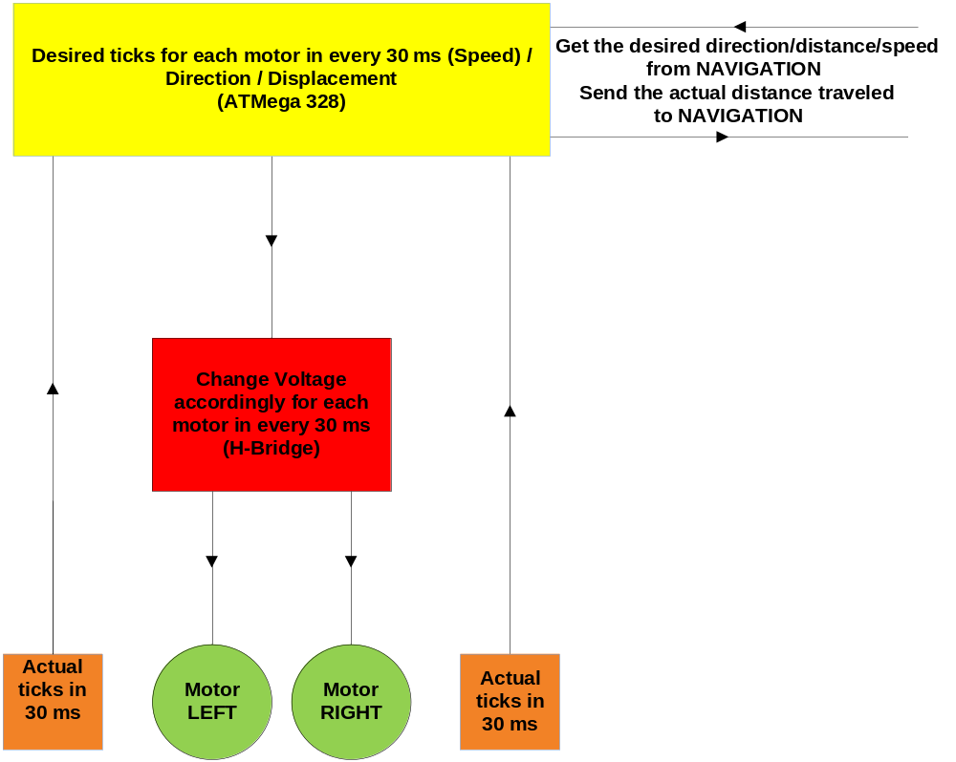

Figure IV: Software inputs and outputs and flow

We have a motor control library in C++ that determines the directions for each motor so in the main program we can just give commands like Motor_Driver.Right(); to turn right.
void Motor_Driver:: Right()
{

digitalWrite(enable_pin_right,HIGH);
digitalWrite(enable_pin_left,HIGH);

digitalWrite(control_1_pin_left,LOW);
digitalWrite(control_2_pin_right,LOW);

pwm_pin_right = control_1_pin_right;

pwm_pin_left = control_2_pin_left;
}
Code Example I: Part of motor_driver.cpp, turn Right() function

Our DC motors did not act similarly under same voltages. Right motor was leading ≈10%. Motor control was needed to make sure they acting similarly under same conditions. Going straight was the main goal. In order to go straight P(ID) control system used to maintain same speed.
Speed Control Algorithm
First we set a desired speed (for example 50 clicks per 30 ms ) then the actual numbers of clicks for each motor counted by interrupts. If the clicks were less than desired 50 clicks we increased the PWM for that motor, if more decreased it. If it was as desired we didn’t make any changes.
Below we see an example of how the code works. The left motor speed is locked to 50 clicks and P(ID) system updates the PWM value (pw_LEFT) in every 30ms with value from the range of -10 to 10 (Output_Left) according to the experimental P determination. It can potentially increase or decrease up to 10 units in every iteration. This is called with timer interrupts for accuracy. Setpoint is the desired distance for the Left Motor to travel and it’s received from the Beagleboard. So this way each motor adjusted itself continuously to keep them close to the desired speed. For example if there was an obstruction for one of the wheel it would increase it’s duty cycle to have same speed as the unobstructed one.
#define SPEED 50
(…..)
PID PID_LEFT(&Input_LEFT, &Output_LEFT, &Speed,PID_P_LEFT ,PID_I_LEFT,PID_D_LEFT);
(……)
if( Setpoint - clicks_LEFT > EPSILON) {
pw_LEFT = pw_LEFT + Output_LEFT;
done_LEFT= 0;
}
(……)
Code Example II: Part of do_PID() function in main_motor_3.pde

We send a done flag for each motor through xml to the USB hub to announce whether we reached our destination by comparing the actual clicks elapsed versus the set point. The navigation has the capability of sending stop anytime and override all the process. Other than they are waiting for the done flags to give new commands. The commands coming from the navigation is in the format of number of clicks desired, and direction.
The maximum speed achieved when we were going full speed ( 100% duty cycle on the left motor since it’s the lagging one) was around 3kHZ signal and corresponded 2.5 feet/sec . Slowest was 0.8 feet/sec.
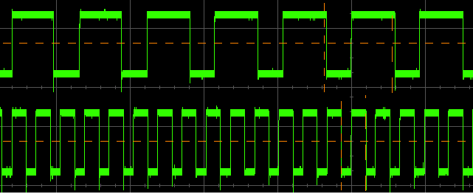
Figure V: Outputs of wheel encoders. 1 kHz on the top and 3 kHz on the bottom.

For the turns with it’s figured out that 1000 clicks in opposite directions = 90° turn. Right turns were more stable than left turns. Beside that the data was fairly linear, for example in order to turn 45°, 500 clicks were necessary.
Here they are all the motor control files we used in the final version. Pde is the arduino IDE’s file format, it’s C++ in essence and accepts C++ libraries.
motor_driver.h /cpp | Motor Control Library/Source
PID_Beta6.h /cpp | PID Control Library/Source³
MsTimer2.h /cpp | Timer Interrupt Library/Source⁴
main_motor_3.pde | Main project that needs to be uploaded to the Arduino Deumilanove
Table III: List of Motor Control sources
A big issue we had was the current spikes at the reset which burned our l298. It seemed like the microcontroller pins were floating at the reset. To fix this issue we added pull down resistors to pull the the logic input to ground at initial conditions. That with extra capacitor parallel to the battery solved the problem. Also we added software protection making sure not to reverse motor directions without pulling down the logic and introducing 10ms delay.
For PID library calculations and click count floats have been used. The limit of the unsigned integer data was 64K and we could have needed more than that many clicks before we reset. We were concerned with this, tried counter integer limitation with introduction of an extra integer value that’s counting revolutions but it didn’t make much of a difference and floats are used.
Conclusions and Recommendations
At the end we were able to go 10 feet straight without deviating more than a foot. For the contest we used a simplified algorithm that adjusted the orientation in every 10 feet to accommodate this constraint. We were able to control the motors from navigation side serially with xml and receive information back after our motor control had been implemented.

Right Motor | Left Motor | Right Motor | Left Motor | Right Motor | Left Motor
254 | 240 | 30 | 27 | 24 | 24
396 | 361 | 31 | 26 | 24 | 25
515 | 466 | 30 | 27 | 24 | 25
1013 | 920 | 29 | 26 | 25 | 24
4301 | 3832 | 30 | 27 | 25 | 25
8299 | 7534 | 29 | 27 | 25 | 24
Table II: First two columns number of clicks (distance) for each motor and the next two are speed without any control at the beginning. Last two colums are the clicks per 30ms (speed) after the latest motor control program.
Having very limited amount of debugging and testing after the whole system was assembled left us with many ideas that could be tested in the future. More motor control or even the whole motor control can be given to the Beagleboard. Instead of waiting for done flags and sending new waypoint and direction, the Beagleboard can take direct control of the motors, slow them down , speed them up, change direction on the fly. The motor system is open to modifications and exploration with its dedicated microcontroller.
Going straight for a long distance is still the biggest challenge. Another idea would be using one single motor for the driving wheels and a servo motor for the turns.

OTHER TASKS
1)3D Model
At the beginning according to the body we envisioned, we did 3D model of the robot in Solidworks to have a conceptual design.
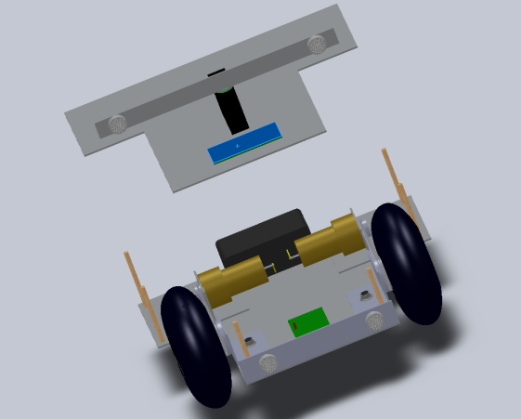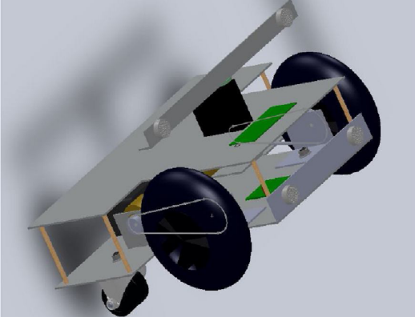

2) The Block Diagram
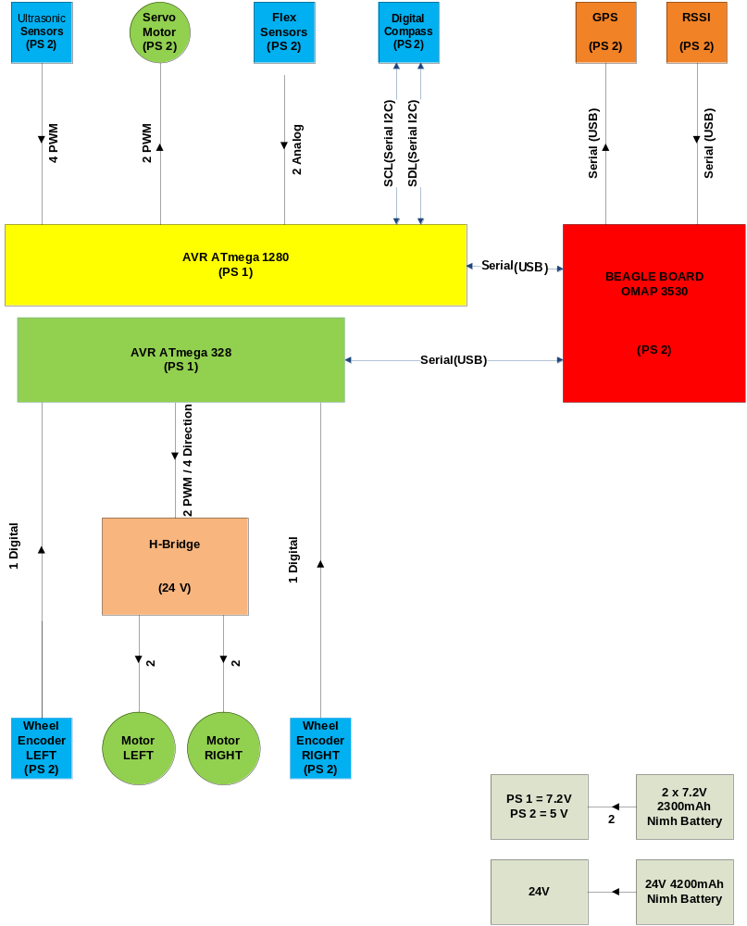

Works Cited:

¹http://www.solarbotics.com/assets/schematics/solarbotics-l298_schematic_complete.jpg

²http://www.canakit.com/Media/Manuals/UK1122.pdf

³http://www.arduino.cc/playground/Code/PIDLibrary
⁴http://www.arduino.cc/playground/Main/MsTimer2

